|  |  |
| --- | --- |
| Assignment Date | 13 September 2022 |
| Student Name | G.Sandhiya |
| Student Roll no. | 510919106014 |
| Maximum Marks | 2 Marks |

Assignment 1

**Basic Python**

**Question-1:**

Split the string

s = "Hi there Sam!"

**Solution:**

string = "Hi there Sam!"

print(string.split())

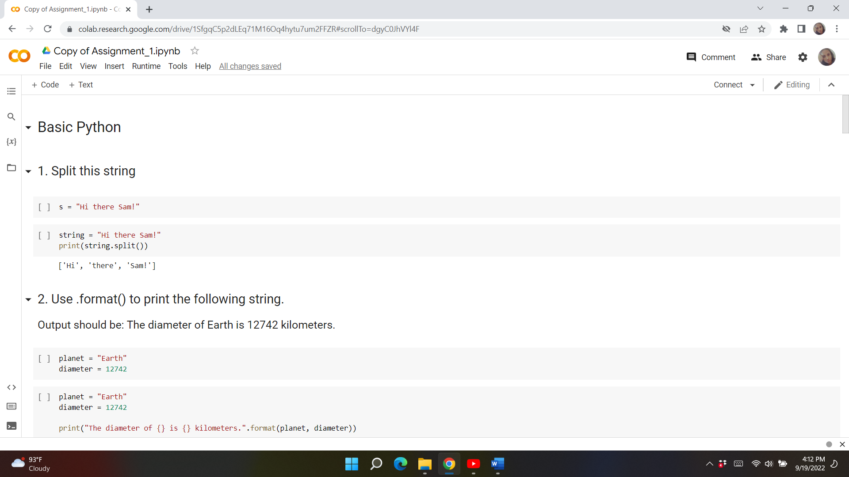

**Question-2:**

Use .format() to print the following string.

Output should be: The diameter of Earth is 12742 kilometers.

planet = "Earth"

diameter = 12742

**Solution:**

planet = "Earth"

diameter = 12742

print("The diameter of {} is {} kilometers.".format(planet, diameter))

#or, you can do it like that:

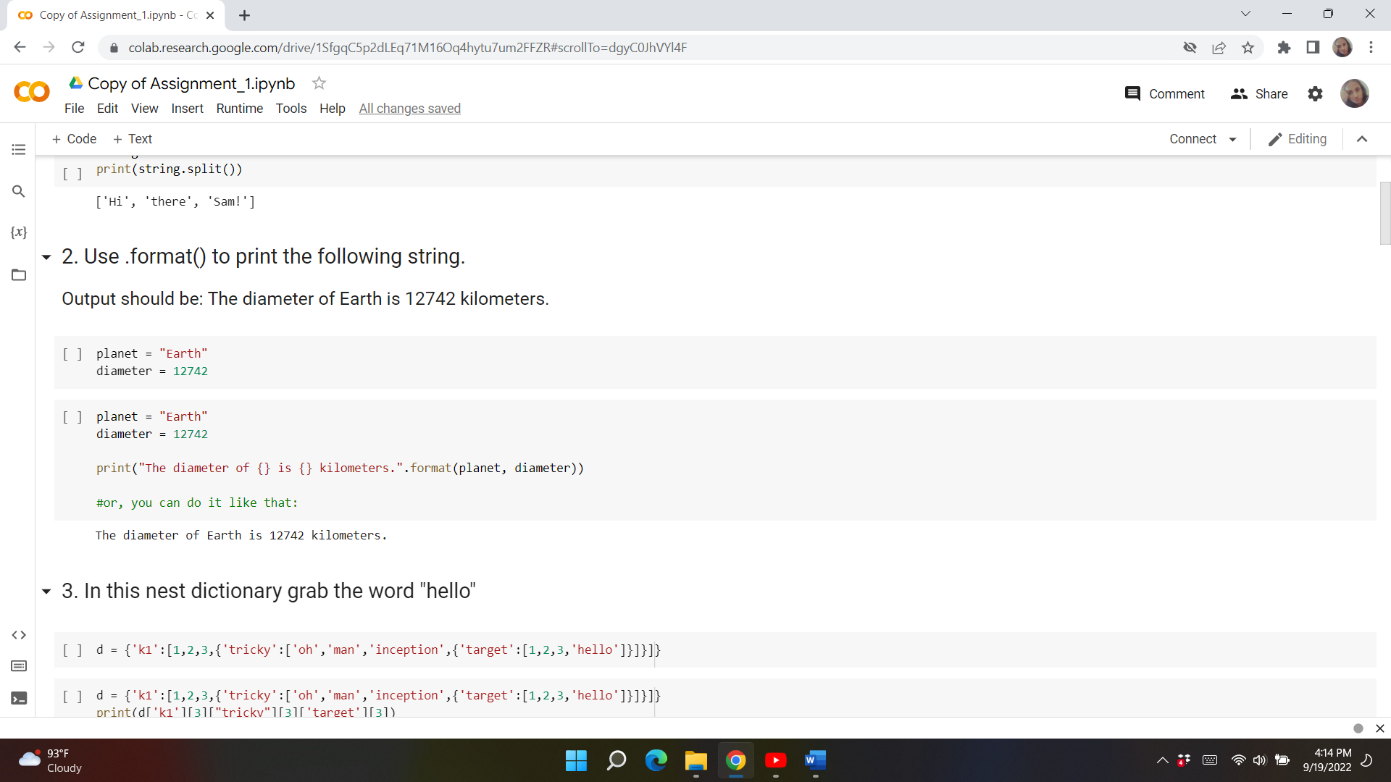

**Question-3:**

In this nest dictionary grab the word "hello"

d = {'k1':[1,2,3,{'tricky':['oh','man','inception',{'target':[1,2,3,'hello']}]}]}

**Solution:**

d = {'k1':[1,2,3,{'tricky':['oh','man','inception',{'target':[1,2,3,'hello']}]}]}

print(d['k1'][3]["tricky"][3]['target'][3])

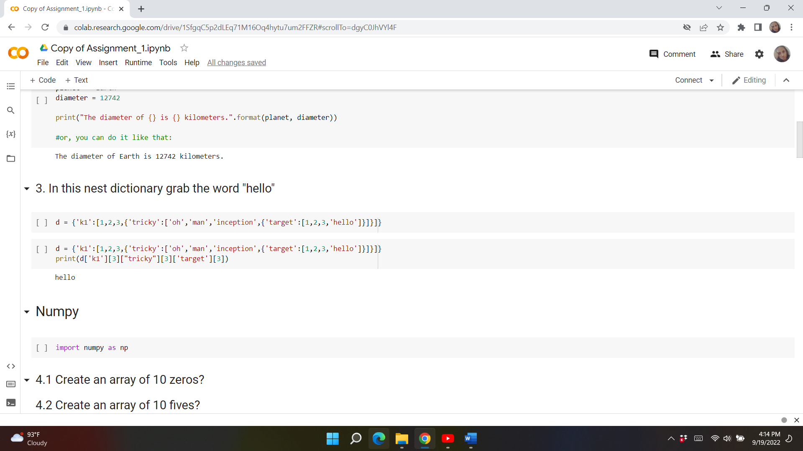

**NumPy**

**Question-4:**

import numpy as np

4.1 Create an array of 10 zeros?

**Solution**:

import numpy as np

array=np.zeros(10)

print("An array of 10 zeros:")

print(array)

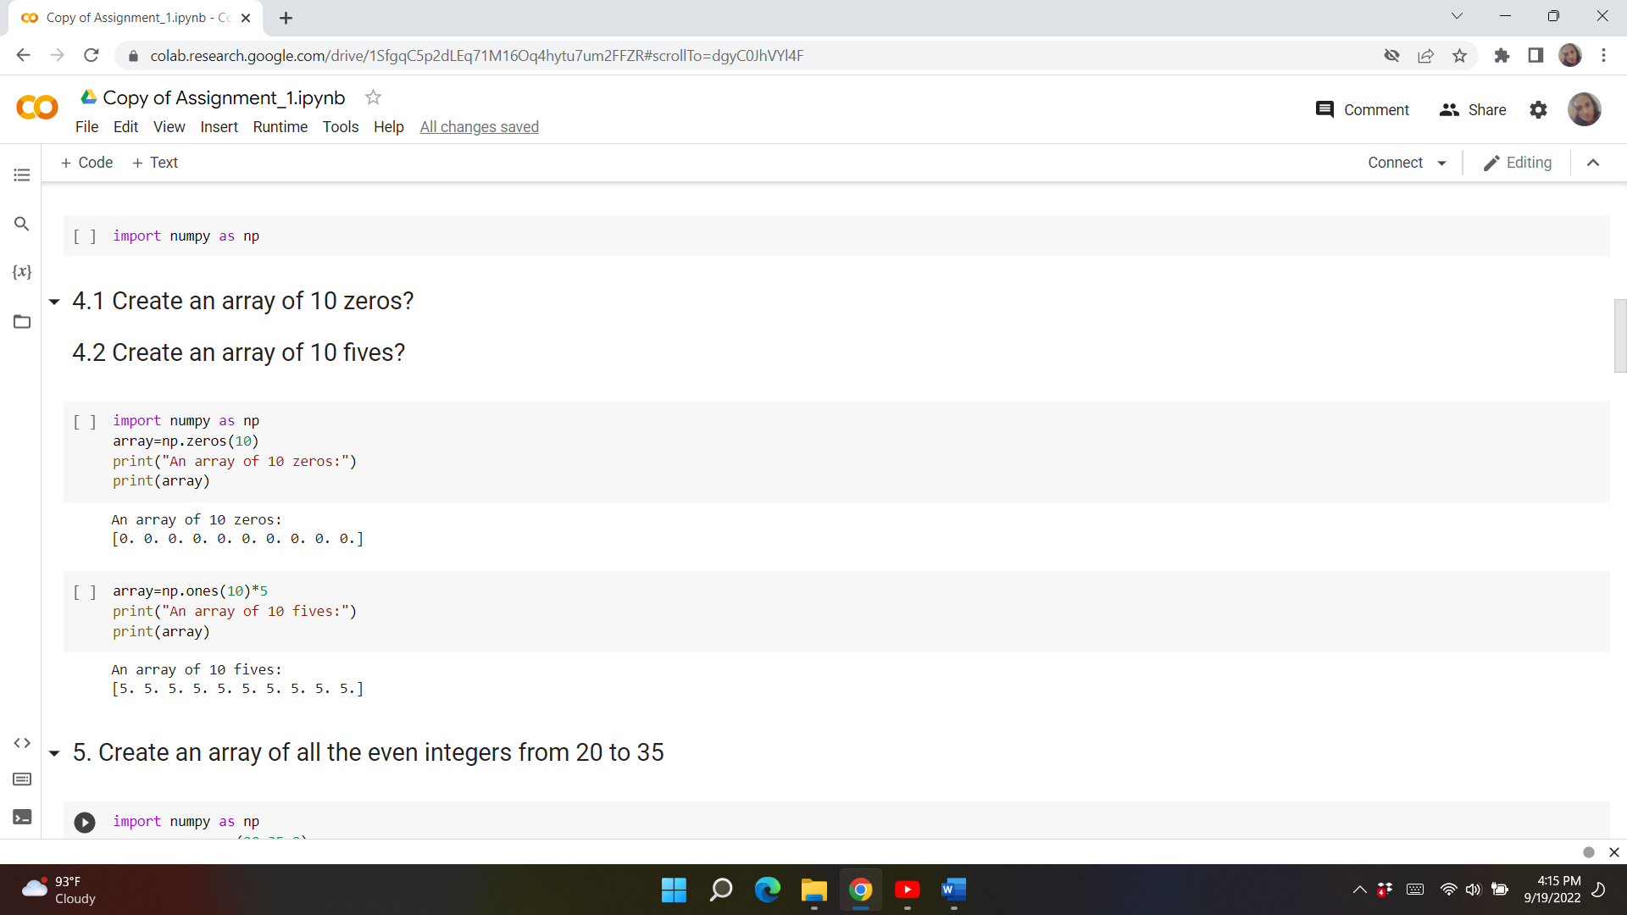

4.2 Create an array of 10 fives?

**Solution**:

array=np.ones(10)*5

print("An array of 10 fives:")

print(array)



**Question-5:**

Create an array of all the even integers from 20 to 35

**Solution:**

import numpy as np

array=np.arange(20,35,2)

print("Array of all the even integers from 20 to 35")

print(array)

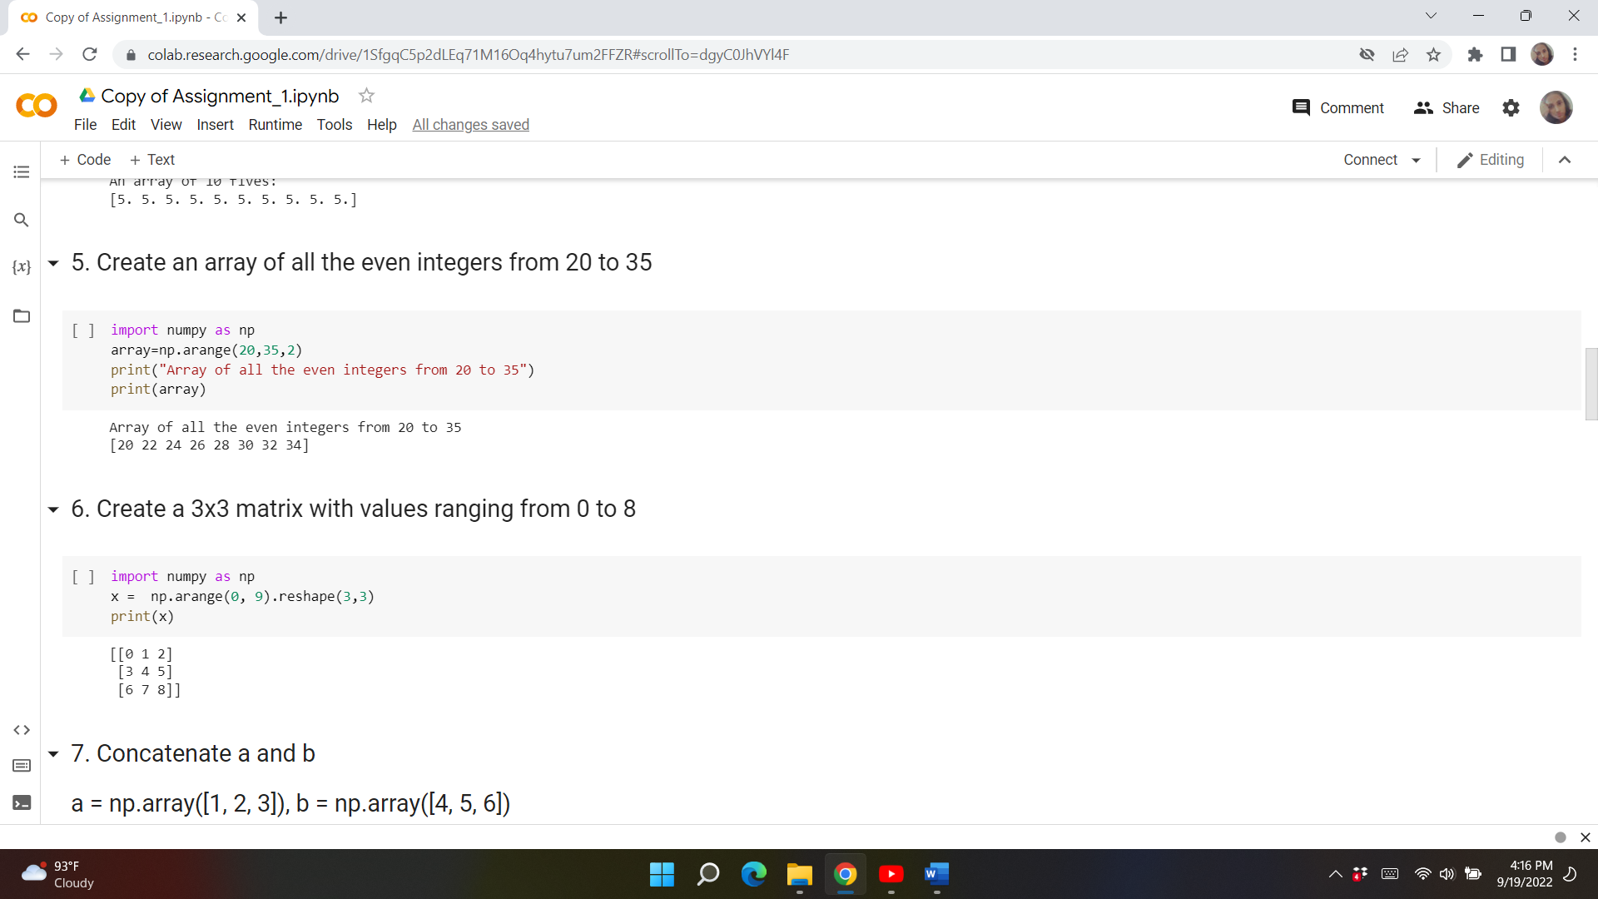

**Question-6:**

Create a 3x3 matrix with values ranging from 0 to 8

**Solution:**

import numpy as np

x =  np.arange(0, 9).reshape(3,3)

print(x)



**Question-7:**

Concatenate a and b

a = np.array([1, 2, 3]), b = np.array([4, 5, 6])

**Solution:**

import numpy as np

a = np.array([1,2,3])

b = np.array([4,5,6])

print(a)

print(b)

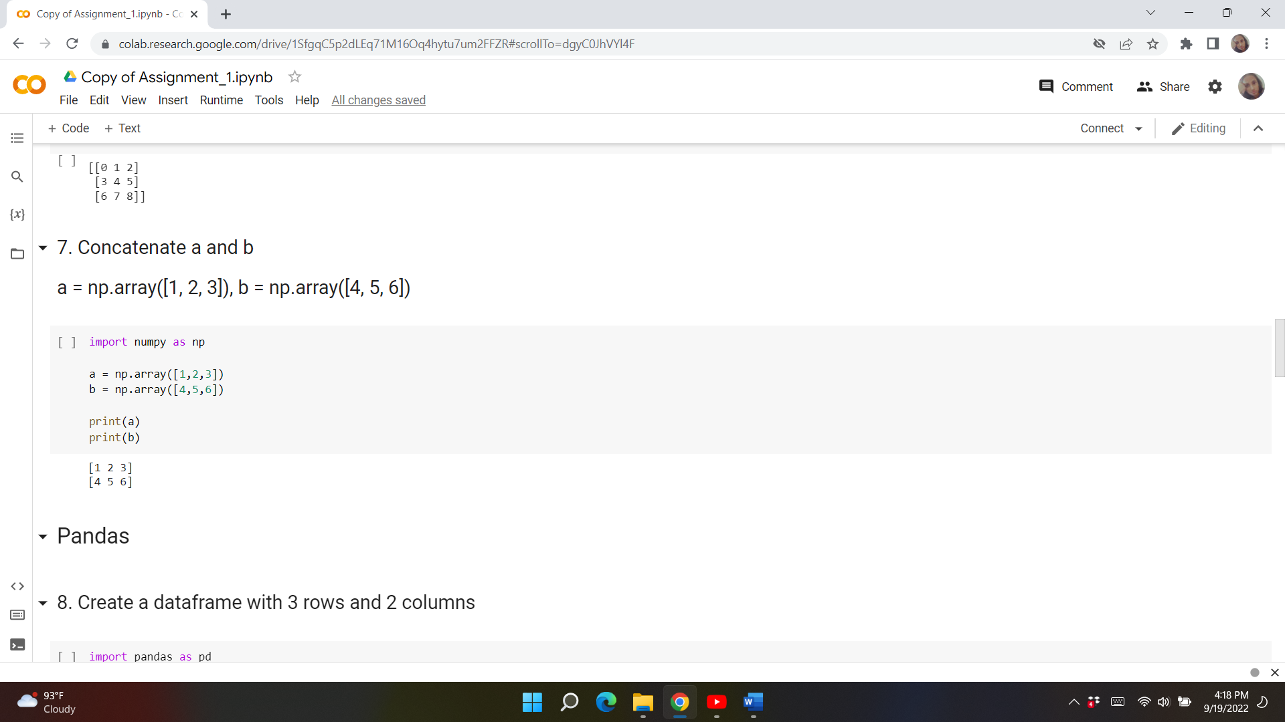

**Pandas**

**Question-8:**

Create a dataframe with 3 rows and 2 columns

import pandas as pd

**Solution:**

# Import pandas library

import pandas as pd

# initialize list of lists

data = [['dhoni', 41], ['kohli', 34], ['rohit',35 ]]

# Create the pandas DataFrame

df = pd.DataFrame(data, columns=['Name', 'Age'])

# print dataframe.

df

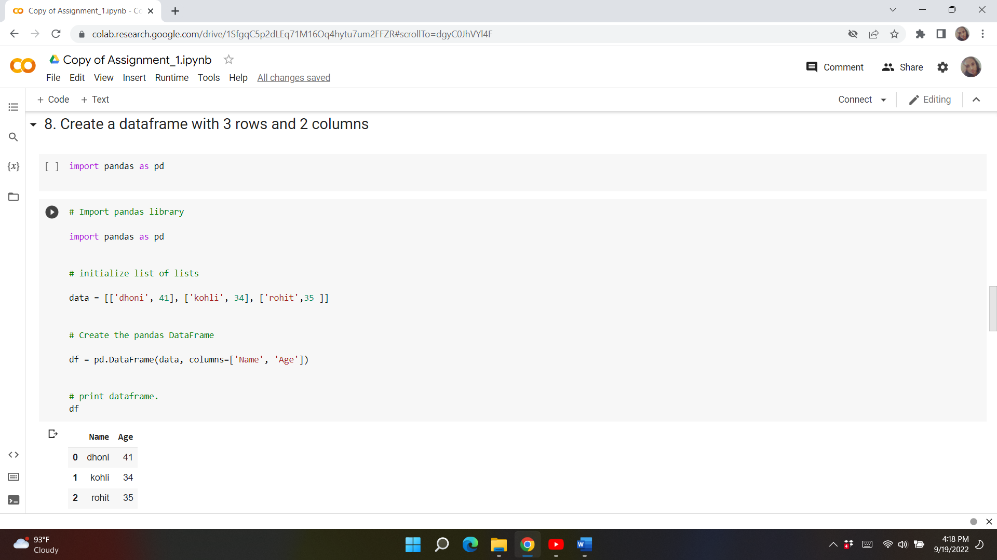

**Question-9:**

Generate the series of dates from 1st Jan, 2023 to 10th Feb, 2023

**Solution:**

# importing pandas as pd

import pandas as pd

per1 = pd.date_range(start ='01-01-2023',

         end ='10-02-2023', freq ='5H')

for val in per1:

    print(val)

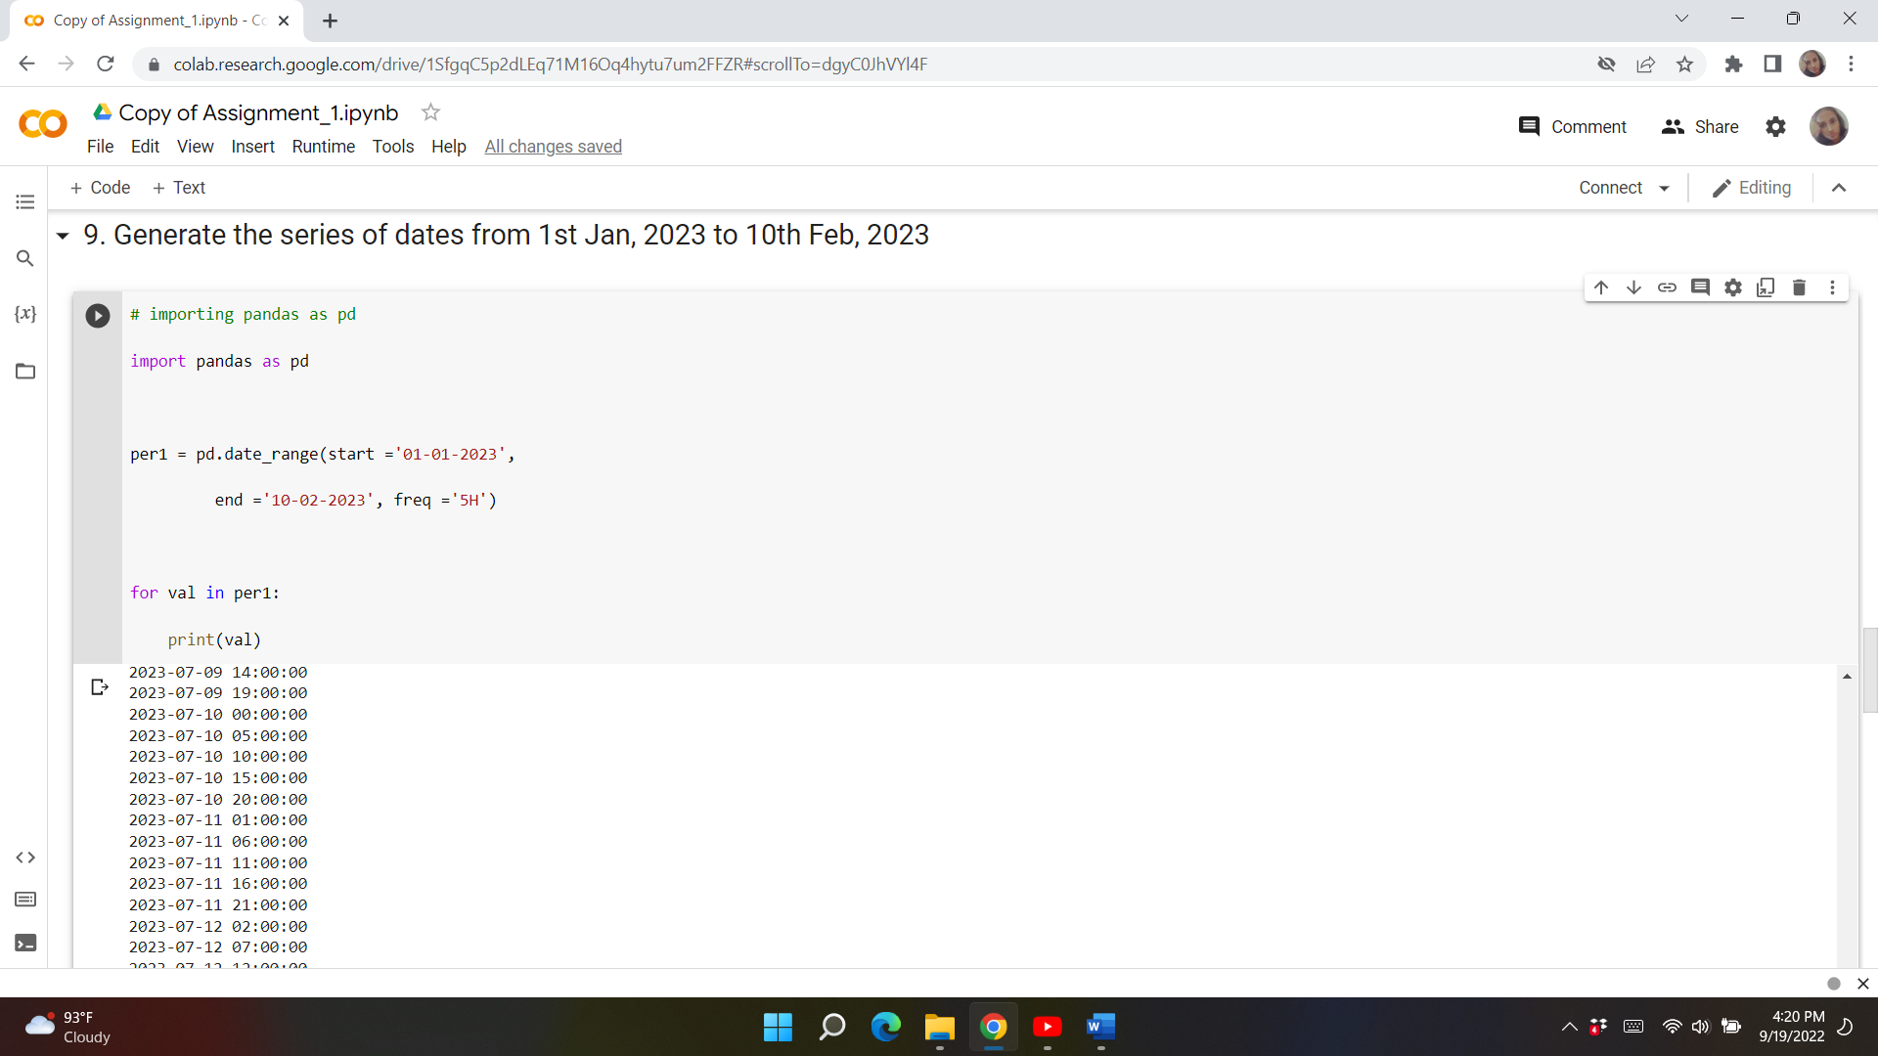

**Question-10:**

Create 2D list to DataFrame

lists = [[1, 'aaa', 22], [2, 'bbb', 25], [3, 'ccc', 24]]

**Solution:**

# Import pandas library

import pandas as pd

# initialize list of lists

data = [['aaa', 22], ['bbb', 25], ['ccc', 24]]

# Create the pandas DataFrame

df = pd.DataFrame(data, columns = ['Name', 'Age'])

# print dataframe.

print(df )

